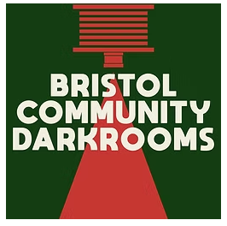
Associate Director Application Form:

We’d like to find out a bit about you so please complete the following questions – feel free to add more space to the boxes. You are welcome to send a CV – this is an optional extra. Please return the form by email to:
info@bristol-community-darkrooms.co.uk
Many thanks!

Name |  | Date
Address |  | Postcode
Phone  Email | Web site (if applicable)  Instagram / other social media
Please provide a short introduction about who you are, your photographic background, experience and practice and any community work you have been involved in, portfolio links welcome.

What skills and expertise can you bring to Bristol Community Darkrooms?

How much time can you contribute now and over the next year?

What do you hope to get out of being an Associate Director?

Please add any additional information that has not been covered in the earlier questions:

Signature

Equality and diversity monitoring form (please tick appropriate answers).
What is your age?

16-24  25-29  30-34  35-39  40-44 
45-49  50-54  55-59  60-64  65+  Prefer not to say 
What is your sex?

Female  Male  Non-Binary/Trans/Other  Prefer not to say 
What is your ethnic background?

Black, African, Caribbean or Black British
African  Caribbean  Other  Prefer not to say 

Asian or British Asian
Indian  Pakistani  Bangladeshi  Chinese  Prefer not to say 

Mixed or Multiple ethnic groups
White and Black Caribbean  White and Black African  White and Asian 
Prefer not to say  Any other Mixed or Multiple ethnic background, please write in:
………………………………………………………………

White
English  Welsh  Scottish  Northern Irish  Irish 
British  Gypsy or Traveller Prefer not to say 
Any other White background please write in:
………………………………………………………………

Other ethnic group
Arab  Prefer not to say  Any other ethnic group, please write in:
……………………………………………………………….

Do you consider yourself to have a disability or health condition?

Yes  No  Prefer not to say 
What is your sexual orientation?

Heterosexual  Gay  Lesbian  Bisexual  Other  Prefer not to say 
What is your religion or belief?

None  Bhuddist  Christian  Hindu  Muslim  Pagan Jewish 
Sikh  Other Prefer not to say 
Are you working?

Full time work  Part time work  Student  Self-employed  Unemployed  Retired  Other  Prefer not to say 

